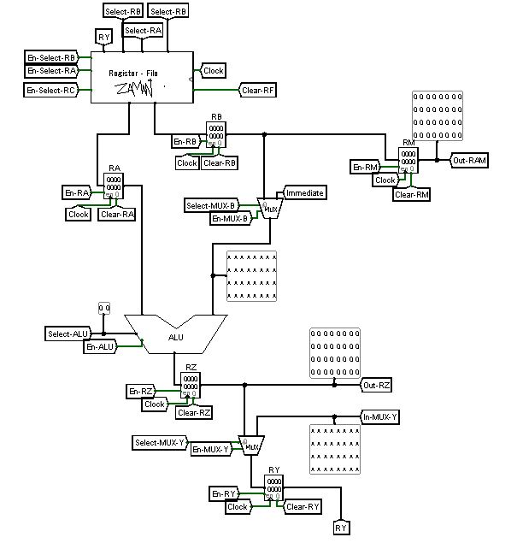

32-bit Processor Design

Zaman Ishtiyaq | 15CS01043 | Autumn Semester 2017

*Contents*

Overall Architecture

Instruction Format

Instruction Set

Components of Processor

Running an Example

# Overall Architecture

|  |  |
| --- | --- |
| 1. General purpose registers | 32 |
| 1. Clock cycles per instruction | 4 |
| 1. Instructions | 8 |
| 1. Memory | R.A.M (18-bit Address &32-bit Data) |
| 1. Special Registers | RA, RB, RC, RZ, RY |

# Instruction Format

OOO AAAAA BBBBB XXXXXXXXXXXXXXXXXXX

|  |  |
| --- | --- |
| OOO | OP-CODE |
| AAAAA | RA |
| BBBBB | RB |
| XXXXXXXXXXXXXXXXXXX | IMMEDIATE |

# Instruction Set

|  |  |  |
| --- | --- | --- |
| **OP-Code** | **Instruction** | **RTN** |
| 000 | LOAD RA, RB, IMMEDIATE | RB 🡨 [ [RA]+IMMEDIATE ] |
| 001 | STORE* RA, RB, IMMEDIATE | [RB] 🡨 [ [RA] +IMMEDIATE] |
| 010 | MOV RA, RB | RB 🡨 [RA] |
| 011 | JUMP RA, RB, IMMEDIATE | PC 🡨 IMMEDIATE |
| 100 | ADD RA, RB | RB 🡨 [RA] + [RB] |
| 101 | SUBTRACT RA, RB | RB 🡨 [RA] - [RB] |
| 110 | MULTIPLY RA, RB | RB 🡨 [RA] * [RB] |
| 111 | DIVIDE RA, RB | RB 🡨 [RA] / [RB] |

* STORE can only write to the RAM so the IMMEDTIATE value should be of the form **1**XXXXXXXXXXXXXXXXXX as Chip-Select has to select RAM otherwise it will try to write on to the ROM and it will have no effect.

# Components of the Processor

Following are the components along with their figures:

1. **Processor Pipeline:**
2. 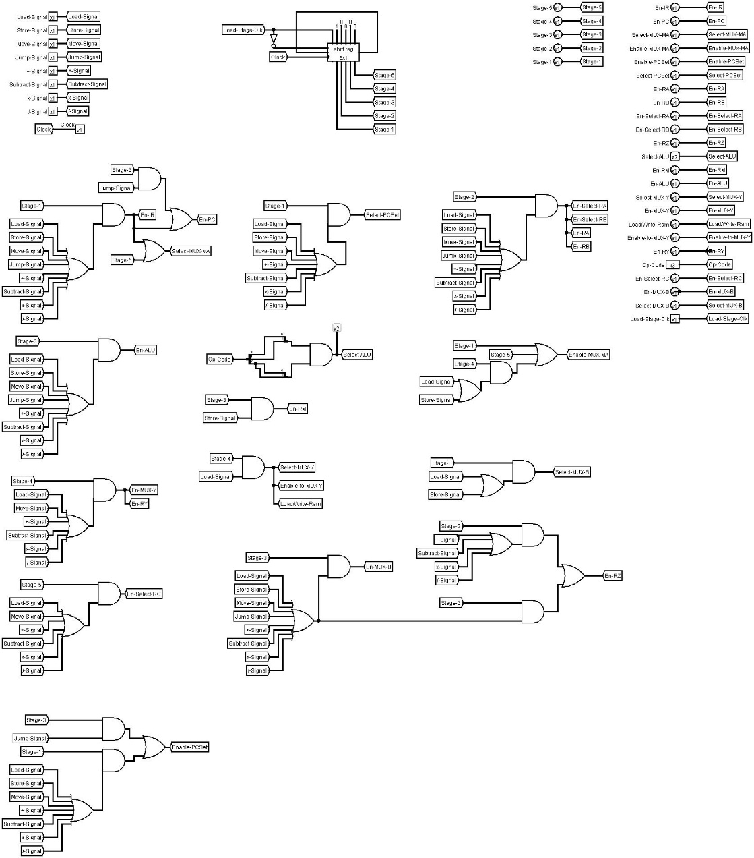**Control Unit**

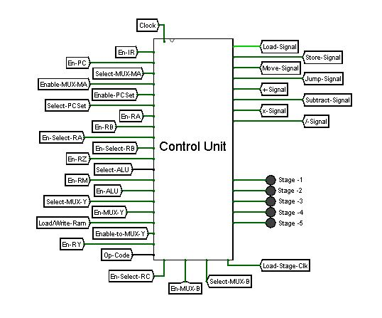

1. **Fetch Unit:**

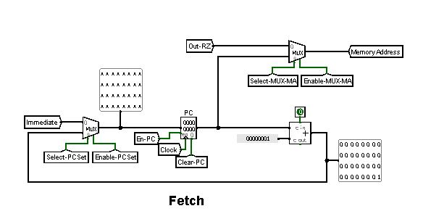Fetch Unit increments the PC or jumps to a new address (Immediate Value) when JUMP command is given.

1. **Instruction Register and Instruction Decoder:**

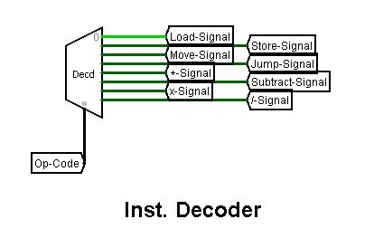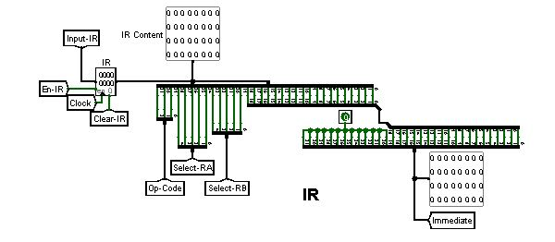

1. **ALU:**

Supports Addition, Subtraction, Multiplication and Division.

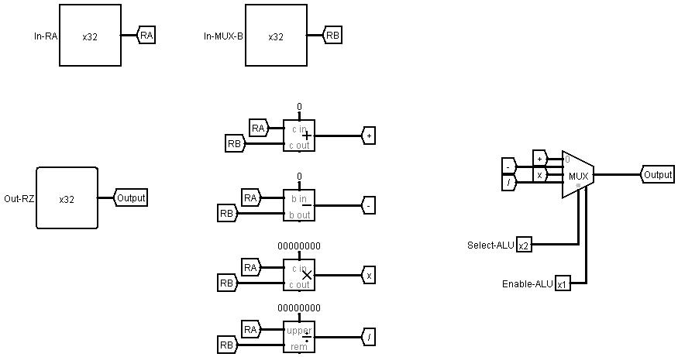

1. **ROM-RAM:**

We write our programs on ROM. ROM and RAM are selected based on Chip Select which changes on different operations.

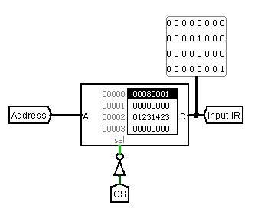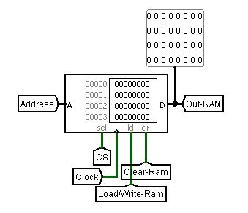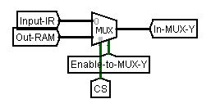

ROM

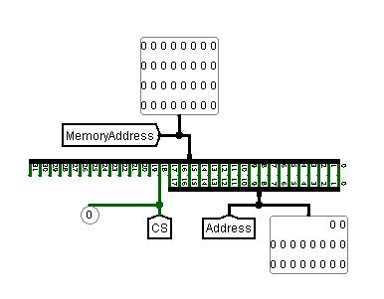

1. **Register File (Internal Circuit):**

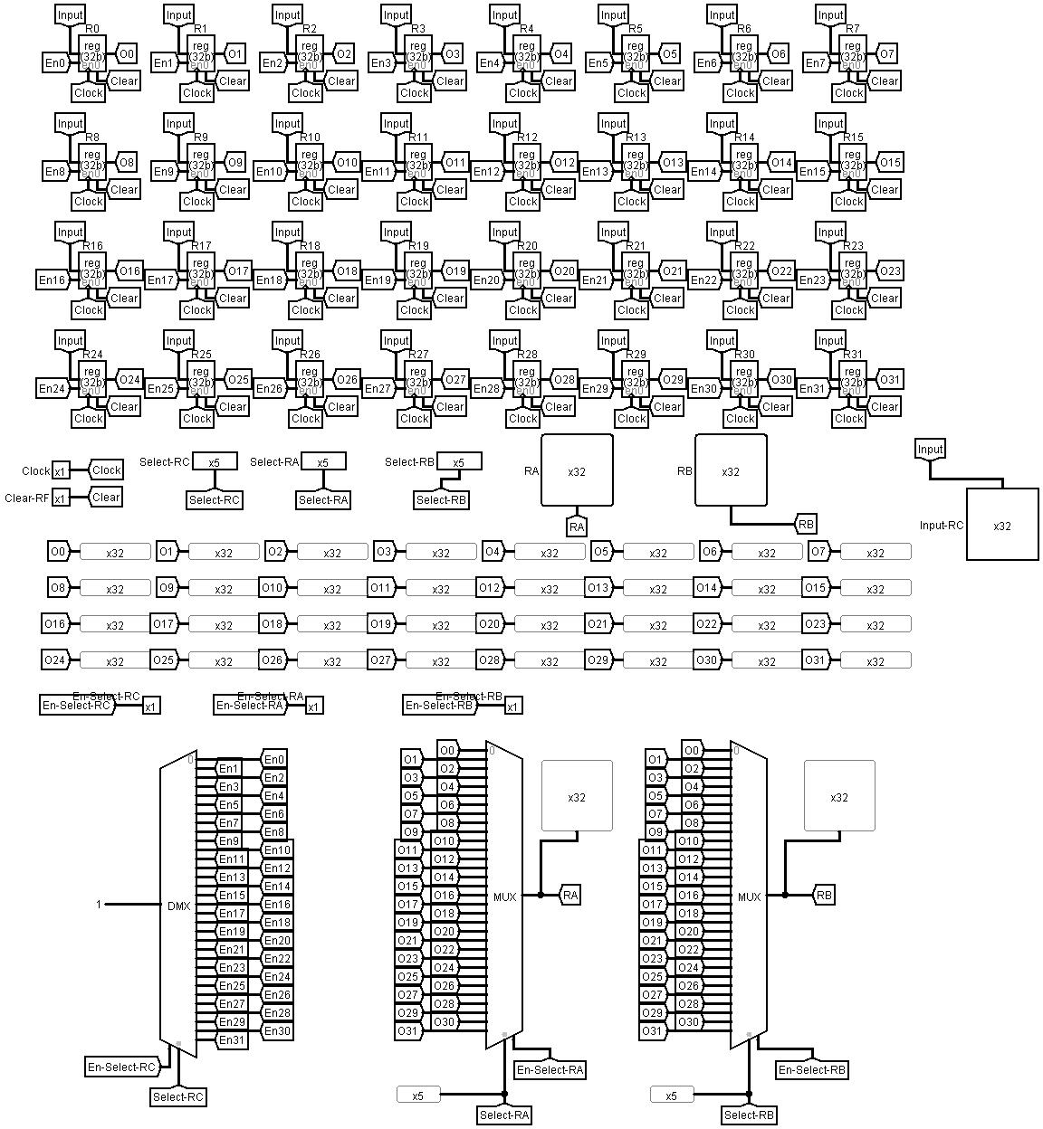

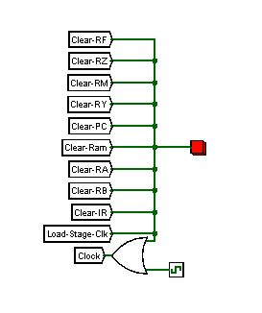9. **Reset Button** Resets Everything except ROM.

# Running an Example

Let us perform the following example:

Initially:

1. Press the RED
2. Change the Register Values in RF to:

**R0**: 1 **R1**: 3 **R2**: 7 **R3**: 6 **R4**: 2 **R5**: 1 **R6**: 2

1. Let’s Load the ROM with the following values:

00000 : 46280000

00001 : 80080000

00002 : a3200000

00003 : c3280000

00004 : e5080000

00005 : 0008000a

00006 : 202c0000

00007 : 6000000f

00008 : 00000000

.

.

.

0000b : 00000011

.

.

.

0000f : 80080000

00010 : 80080000

When Executed following happens:

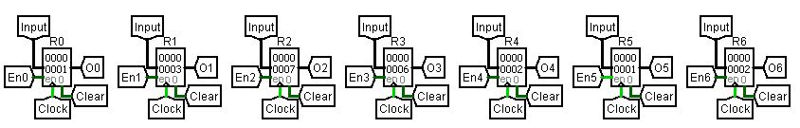Initially the RF looks like :

**R0**: 1 **R1**: 3 **R2**: 7 **R3**: 6 **R4**: 2 **R5**: 1 **R6**: 2

1. 46280000 in binary is 01000110001010000000000000000000

i.e. MOV R6, R5

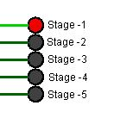

* **Stage – 1: Fetch to IR**

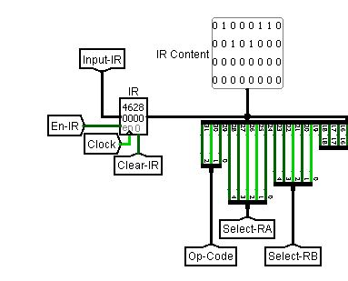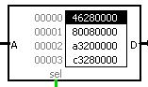

* **Stage – 2: RA gets value from R6**

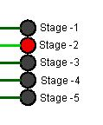

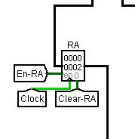RA 🡨 [R6]

* **Stage – 3: RA gets value from R6**

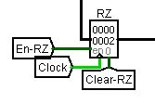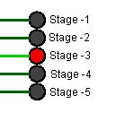

RA’s value passes unchanged through ALU to RZ

* **Stage – 4: RY gets value from RZ**

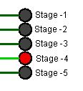

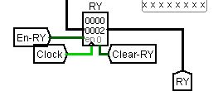

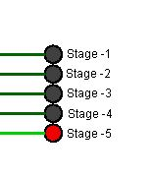

* 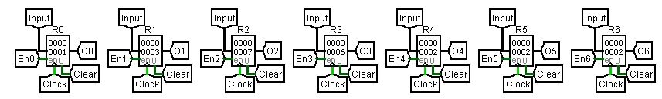**Stage – 5: R5 gets value from RZ**

Values Now:

**R0**: 1 **R1**: 3 **R2**: 7 **R3**: 6 **R4**: 2 **R5**: 2 **R6**: 2

And PC is incremented to next instruction :

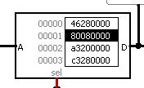

1. 80080000 in binary is 100 00000 00001 0000000000000000000

i.e. ADD R0, R1 or R1 🡨 [R0] + [R1]

* **Stage – 1: Fetch to IR**

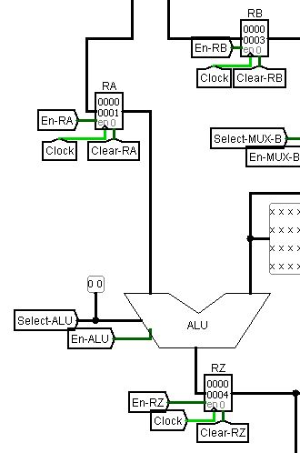Similar to above

* **Stage – 2: RA, RB get their values from RF**
* **Stage – 3: ALU performs addition**
* **Stage – 4: RY gets value from RZ**
* **Stage -5: R1 gets value from RY and PC++**

i.e. R1 🡨 1 + 3 (=4)

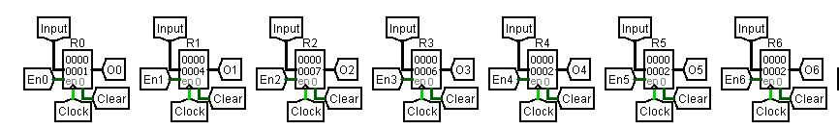

Values Now:

**R0**: 1 **R1**: 4 **R2**: 7 **R3**: 6 **R4**: 2 **R5**: 2 **R6**: 2

1. a3200000 in binary is 101 00011 00010 0000000000000000000

i.e. SUB R3, R4 or R4 🡨 [R3] - [R4]

* **Stage – 1: Fetch to IR**

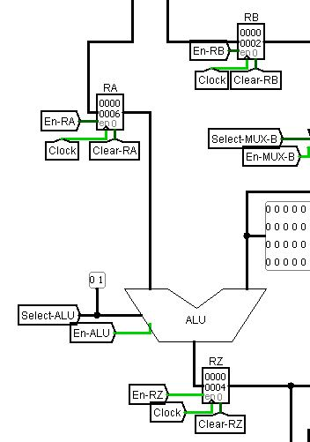

* **Stage – 2: RA, RB get their values from RF**
* **Stage – 3: ALU performs Subtraction**
* **Stage – 4: RY gets value from RZ**
* **Stage -5: R4 gets value from RY and PC++**

i.e. R4 🡨 6 - 2 (=4)

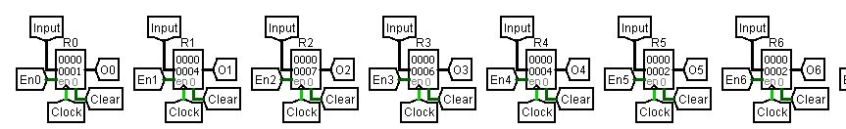

Values Now:

**R0**: 1 **R1**: 4 **R2**: 7 **R3**: 6 **R4**: 4 **R5**: 2 **R6**: 2

1. c3280000 in binary is 110 00011 00101 0000000000000000000

i.e. MUL R3, R5 or R5 🡨 [R3] * [R5]

* **Stage – 1: Fetch to IR**

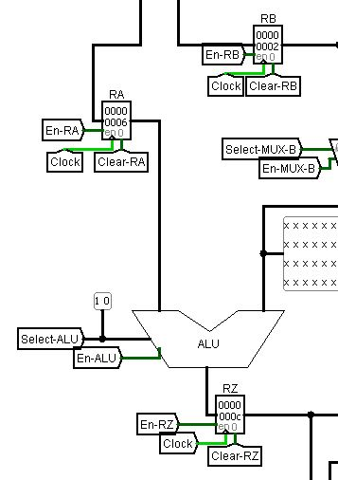

* **Stage – 2: RA, RB get their values from RF**
* **Stage – 3: ALU performs Multiplication**
* **Stage – 4: RY gets value from RZ**
* **Stage -5: R5 gets value from RY and PC++**

i.e. R5 🡨 6 * 2 (=12)

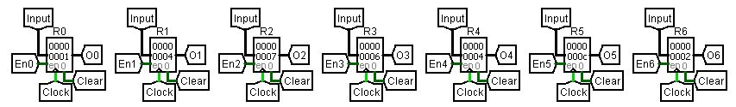

Values Now:

**R0**: 1 **R1**: 4 **R2**: 7 **R3**: 6 **R4**: 4 **R5**: 12 **R6**: 2

1. e5080000 in binary is 111 00101 00001 0000000000000000000

i.e. DIVIDE R5, R1 or R1 🡨 [R5] / [R1]

* **Stage – 1: Fetch to IR**
* **Stage – 2: RA, RB get their values from RF**

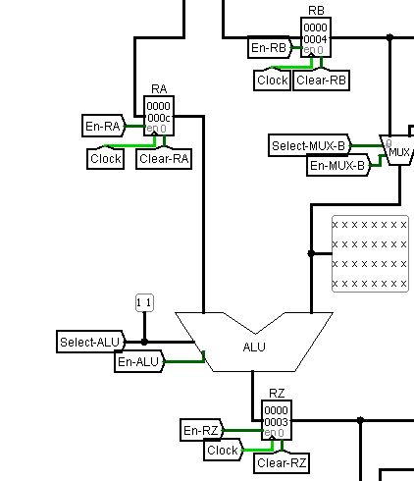

* **Stage – 3: ALU performs Division**
* **Stage – 4: RY gets value from RZ**
* **Stage -5: R1 gets value from RY and PC++**

i.e. R5 🡨 12 / 4 (=3)

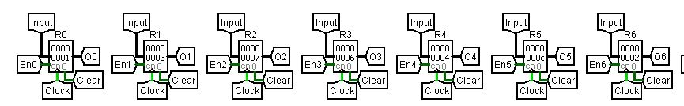

Values Now:

**R0**: 1 **R1**: 3 **R2**: 7 **R3**: 6 **R4**: 4 **R5**: 12 **R6**: 2

1. 0008000a in binary is 000 00000 00001 0000000000000001010

i.e. LOAD R0, R1, #10 or R1 🡨 [ [R0] + 10 ]

* 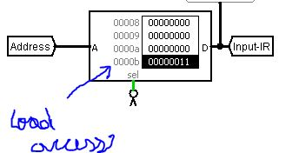**Stage – 1: Fetch to IR**
* **Stage – 2: RA get their values from RF, RB gets IMMEDIATE value**
* **Stage – 3: ALU performs Addition, RY gets the address to be read from**
* **Stage – 4: RY gets value from the ROM/RAM at address in RY**
* **Stage -5: R0 gets value from RY and PC++**

i.e. R0 🡨 [ [1 + 10] ] which is 0000b location on ROM and the value there is

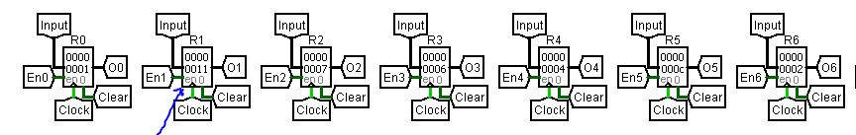000000011 , therefore R0 <- 00000011 or 17

Values Now **R0**: 1 **R1**: 17 **R2**: 7 **R3**: 6 **R4**: 4 **R5**: 12 **R6**: 2

1. 202c0000 in binary is 001 00000 00010 1000000000000000000

i.e. STORE R0, R5, #0 or [R0] + 0 🡨 [R5] i.e. RAM gets written at this location by [R5]

* 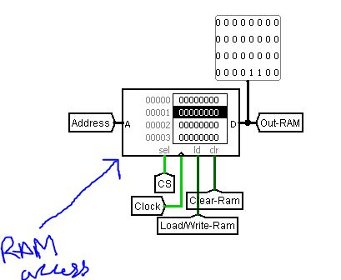**Stage – 1: Fetch to IR**
* **Stage – 2: RA get their values from RF, RB gets IMMEDIATE value**
* **Stage – 3: ALU performs Addition, RY gets the address to be write onto, RM gets value of R5**
* **Stage – 4: Value of RM is written on the address in RY**
* 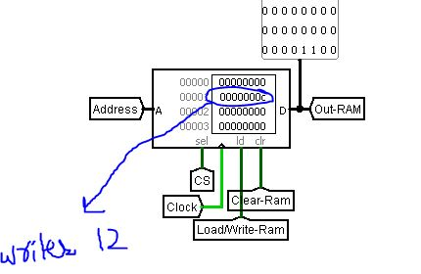**Stage -5: PC++**

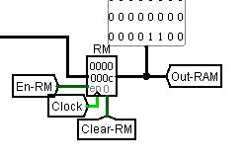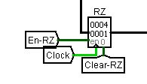

1. 6000000f in binary is 011 00000 00000 00000000000000001111

i.e. JUMP IMMEDIATE or PC 🡨 location 0000f on ROM

* **Stage – 1: Fetch to IR**

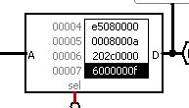

* **Stage – 2: -**
* **Stage – 3: MUX-PCSet is Enabled and IMMEDIATE is Selected**
* **Stage – 4: PC gets value of IMMEDIATE**
* 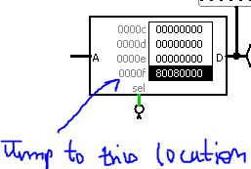**Stage -5: PC++**

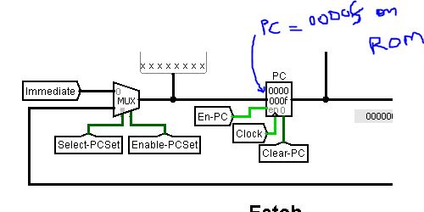

Now the further instructions are executed from this point onwards.